Newsletter
Afton Historical Society
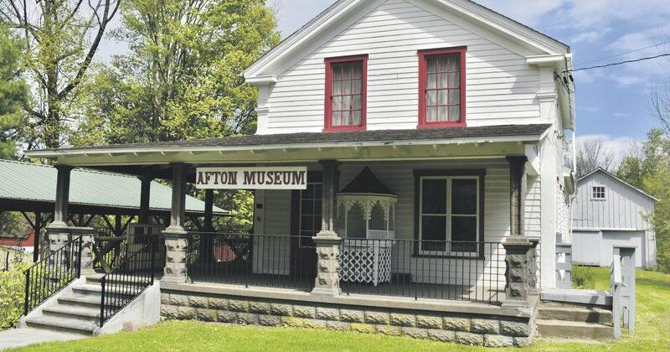

Upcoming Events

2024 Season Opening Date
May 25, 2024 1-4pm
Member input is important to us in our planning events.
Feel free to email us your ideas at Aftonhistsoc@yahoo.com
YARD SALE APRIL 27, 2024
Items Wanted !
Call 919-884-0785 or 607-242-8180 to schedule donation drop-offs. Thank you.

Important Announcement
AHS Meetings
First Saturday of the Month, 10am, Afton Historian Office / Town Meeting Room
To accommodate then next generation of Volunteers who still have work schedules.

116 Main Street, PO Box 142, Afton, NY 13730
Website: www.Aftonhistoricalsociety.org
Telephone: 607-639-1110
By Email: Aftonhistsoc@yahoo.com
Facebook: www.facebook.com/HistoricalAfton
Dear Member,
Thank you for your continued support of the Afton Historical Society.
We wouldn’t be here if it wasn’t for you.
Together we will continue to make the Afton Historical Society a place that people want to come visit from near and far.
Sincerely, the Board of Directors

A Bit O’ History
The Afton Historical Society as we know it today was begun by an ambitious group of women, known as the D.A.R. (Daughters of the American Revolution), and many helping hands in the early 1980’s.
Without their ground breaking work to create a home for Afton’s Historical Collections of items, and all the volunteers and supportive members near and far that have come and assisted in all matters since, we would not be here today.
The founding members were: Dorothy Thompson, Helen Edson, Mildred Reynolds, Patricia Stafford, and Lynette Baciuska.
And all who have contributed since.
We thank you, and hope to provide excellence in the continuation of the Afton Historical Society.

Important News

In the Community

Museum Open Hours
Memorial Day – Labor Day
Saturdays 1pm – 4pm
Or by Appointment by calling 607-743-3139 or 607-639-1110

2024 Calendars for Sale
If you haven’t gotten your Afton Historical Society Calendar yet, we still have some !
$6.00 each. (s & h added if shipped.)
They are available at the Afton Historical Society, the Afton Library, Horton Hardware, and at The Old Tome Emporium / Bookstore. All located on Main Street in Afton.
2024 Calendar Theme
“Preserving the Past, for the Future.”
Goal: To sell ALL calendars so proceeds can further better our Museum.
These make amazing collectors items also.

The past year has brought many new members and volunteers to the AHS. It is grand to see the membership still growing, and the younger generations becoming involved.
To all who have come before, we graciously thank you for your many years of dedicated service to Afton’s Historical Society.
AHS Board of Directors & Officers 2024
Member Term Office
- Paul Stack 1/2024 – 12/2026 President
- Melanie Hager 1/2024 – 12/2026 V. President
- Destiny Case 1/2023 – 12/2025 Curator
- Tracy DeMatteo 1/2022 – 12/2024 Secretary
- Angelina Mueller 1/2022 – 12/2024 Treasurer
- Maryann Palmetier 1/2022 – 12/2024
- Alton Prentice 1/2023 – 12/2025
Who’s Who
Paul Stack, since childhood, has a deep desire to investigate history of our world and is an Aftonite, belonging to one of the oldest farm families in Afton.
Melanie Hager is Afton’s Historian. Her research abilities and intelligence in many areas is a grand asset to the AHS. The Historian and the Afton Historical Society, as per the by-laws, have always worked together to ensure the best preservation abilities for Afton’s History.
Destiny Case brings with her a deep desire to preserve history, and education she gained while working at the Chenango County Museum. A grand asset to AHS.
Tracy DeMatteo’s family has donated many items to the Afton Historical Society. She has been involved with many organizations as their secretary and treasurer, including D.A.R. and O.E.S. She brings decades of knowledge on organizational operations with her to AHS.
Angelina Mueller is our youngest board member. She began her volunteering locally and entrepreneurship life at 6 years old when she began the “Bad Sandy Healing Bags” to raise money for the Hurricane Victims of Staten Island. Over 8 years of being Afton’s Girls Scout with highest sales. In School, she loves her math, especially her financial math.
Maryann Palmetier has been an active part of Afton and giving herself selflessly to the community in all ways that she can. The Pastor of Afton’s Hope Congregational Church, she never denies helping hands or words of wisdom to those who ask. She brings with her years of knowledge.
Alton Prentice is the Afton Historical Society handyman. Making repairs, tending snow, weeding flower beds, painting, and much more. Anytime his community needs him, he has been happy to assist.

What’s Been Happening….
The Board has been busy putting in extra work hours preparing for the arrival of sunny weather and the museums open doors Memorial Weekend.
Handicap Accessible. – Our handicap ramp needed some TLC at the bottom of the ramp. Trustee Al has donated his time, effort, and materials to fixing the broken end with Diamond Plate that will last much longer than the thin wood piece that once was.
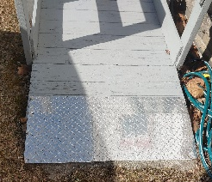
Handicap Enjoyment - There are also plans of making the tour of the museum more handicapped accessible. It’s a bit of work, but it will ensure a better experience for all, and that’s what matters.

More Important News
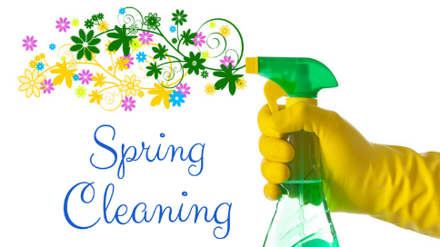

Your Support Helps !

Volunteer
Volunteer to assist with fundraising, functions, etc.
Volunteering doesn’t need to be a zillion hours. Even a single hour here or there helps.

Membership
If you haven’t renewed your Membership for 2024, please do !
Interested in being a New Member?
Membership forms are available to print at aftonhistoricalsociety.org

Purchase
The Afton Historical Society has many items available for sale such as mugs, calendars, old year books, and much more…. Every purchase helps!

Donations
With every Non-Profit, Donations are the biggest difference. Future events, internships, and upkeep of building and collections are possible thanks to the support of financial contributions.

Winter 2023/2024
We have been graced with a mild winter. This year, we were also graced with free snow plowing from Al Prentice. Local teens have donated their time to keeping our sidewalks clear. Thank you to all.
Website
Our website www.aftonhistoricalsociety.org has valuable information such as Items for Sale, meeting minutes, a printable membership form, and other items of interest. We ask that you please share the word so that the Historical Society can continue to thrive.
Expenses
To Date:
- Phone/Internet bill has been reduced by $20 per month.
- 4 heat registers have been unblocked, allowing heat to enter the home better, thus reducing heating costs.

Spring Cleaning.
It begins now ! So that in the spring we can enjoy the fruits of our labor & the sunshine !!! Nobody likes “Spring Cleaning” inside while the sun is shining outside. We have begun doing deep cleaning, nooks & crannies.
The younger Board Members are a great help. They are able to get down & do things that become difficult to do as people age.
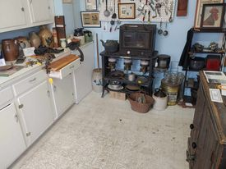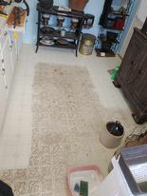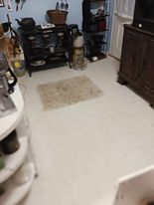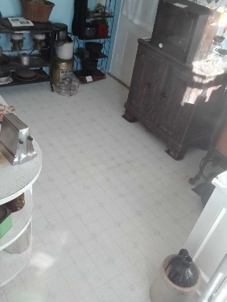
Our kitchen floor was one of the items that needed some of that younger TLC. Photos show Before, During, and After.
Items for Sale
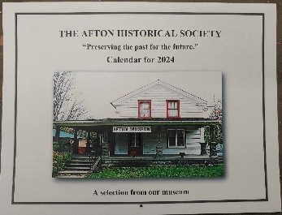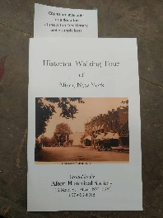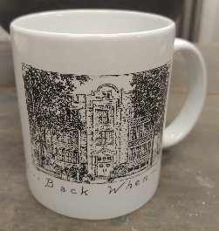
2024 Calendar Mug Style #1 Walking Tour Mug Style #2
Other items for sale include old Afton Yearbooks, Post Cards, and past year Calendars.
Newsletters
Currently, we are unsure how many newsletters we will be able to send throughout the year. There have been 2 a year in past years. We hope to be able to increase that.
The website and facebook page will always be updated with up coming events, etc.
Please follow www.facebook.com/HistoricalAfton, and www.aftonhistoricalsociety.org to stay up to date.
Thank you for being a supporter of the Afton Historical Society.

